Tanmay_Agarwal_Airline_Code.R

Tanmay

Thu Jul 06 05:51:29 2017

# ANALYSIS OF AIRLINE TICKET PRICING  
# NAME: TANMAY AGARWAL  
# EMAIL: tanmay151997@gmail.com   
# COLLEGE: R.V. COLLEGE OF ENGINEERING  
  
# We will be analyzing the pricing of Premium Economy tickets relative   
# to regular Economy airline tickets.  
  
# Reading the data set from the working directory  
  
# First setting the working directory  
  
setwd("C:/Users/Tanmay/Desktop/Data Science and Analytics and Programming in R/Mini Project 1/SIxAirlines")  
  
# Reading the data using R command  
  
airline.df<-read.csv(paste("SixAirlinesData.csv", sep = ""))  
  
# Summarizing the data set  
  
summary(airline.df)

## Airline Aircraft FlightDuration TravelMonth  
## AirFrance: 74 AirBus:151 Min. : 1.250 Aug:128   
## British :175 Boeing:311 1st Qu.: 4.250 Jul: 76   
## Delta : 46 Median : 7.750 Oct:128   
## Jet : 65 Mean : 7.549 Sep:130   
## Singapore: 40 3rd Qu.:10.500   
## Virgin : 62 Max. :14.660   
## IsInternational SeatsEconomy SeatsPremium PitchEconomy   
## Domestic : 40 Min. : 17.0 Min. : 8.00 Min. :30.00   
## International:422 1st Qu.:127.0 1st Qu.:21.00 1st Qu.:31.00   
## Median :185.0 Median :36.00 Median :31.00   
## Mean :200.7 Mean :33.54 Mean :31.21   
## 3rd Qu.:243.0 3rd Qu.:40.00 3rd Qu.:32.00   
## Max. :389.0 Max. :66.00 Max. :33.00   
## PitchPremium WidthEconomy WidthPremium PriceEconomy   
## Min. :34.00 Min. :17.00 Min. :17.00 Min. : 65.0   
## 1st Qu.:38.00 1st Qu.:17.00 1st Qu.:19.00 1st Qu.: 404.8   
## Median :38.00 Median :18.00 Median :19.00 Median :1224.0   
## Mean :37.92 Mean :17.83 Mean :19.48 Mean :1317.1   
## 3rd Qu.:38.00 3rd Qu.:18.00 3rd Qu.:21.00 3rd Qu.:1903.0   
## Max. :40.00 Max. :19.00 Max. :21.00 Max. :3593.0   
## PricePremium PriceRelative SeatsTotal FractionPremiumSeats  
## Min. : 86 Min. :0.0200 Min. : 38.0 Min. :0.0500   
## 1st Qu.: 524 1st Qu.:0.1000 1st Qu.:162.0 1st Qu.:0.1200   
## Median :1710 Median :0.3800 Median :227.0 Median :0.1300   
## Mean :1832 Mean :0.4926 Mean :234.2 Mean :0.1503   
## 3rd Qu.:2989 3rd Qu.:0.7475 3rd Qu.:279.0 3rd Qu.:0.1500   
## Max. :7414 Max. :1.8900 Max. :441.0 Max. :0.5500   
## PitchDifference WidthDifference  
## Min. : 2.000 Min. :0.000   
## 1st Qu.: 6.000 1st Qu.:1.000   
## Median : 7.000 Median :1.000   
## Mean : 6.716 Mean :1.654   
## 3rd Qu.: 7.000 3rd Qu.:3.000   
## Max. :10.000 Max. :4.000

# loading some packages  
  
library("car", lib.loc="~/R/win-library/3.4")  
library("caTools", lib.loc="~/R/win-library/3.4")  
library("corrgram", lib.loc="~/R/win-library/3.4")

## Warning: package 'corrgram' was built under R version 3.4.1

library("corrplot", lib.loc="~/R/win-library/3.4")  
library("gmodels", lib.loc="~/R/win-library/3.4")  
library("gplots", lib.loc="~/R/win-library/3.4")

##   
## Attaching package: 'gplots'

## The following object is masked from 'package:stats':  
##   
## lowess

library("Matrix", lib.loc="~/R/win-library/3.4")  
library("psych", lib.loc="~/R/win-library/3.4")

##   
## Attaching package: 'psych'

## The following object is masked from 'package:car':  
##   
## logit

library("lattice", lib.loc="C:/Program Files/R/R-3.4.0/library")  
  
# Describing the data set to know the mean, meadian, standard deviation, etc.  
  
describe(airline.df)

## vars n mean sd median trimmed mad  
## Airline* 1 462 3.02 1.65 2.00 2.90 1.48  
## Aircraft* 2 462 1.67 0.47 2.00 1.72 0.00  
## FlightDuration 3 462 7.55 3.54 7.75 7.54 4.82  
## TravelMonth* 4 462 2.56 1.17 3.00 2.58 1.48  
## IsInternational* 5 462 1.91 0.28 2.00 2.00 0.00  
## SeatsEconomy 6 462 200.71 77.96 185.00 193.76 85.99  
## SeatsPremium 7 462 33.54 13.26 36.00 33.20 11.86  
## PitchEconomy 8 462 31.21 0.66 31.00 31.25 0.00  
## PitchPremium 9 462 37.92 1.32 38.00 38.06 0.00  
## WidthEconomy 10 462 17.83 0.56 18.00 17.81 0.00  
## WidthPremium 11 462 19.48 1.10 19.00 19.54 0.00  
## PriceEconomy 12 462 1317.06 989.81 1224.00 1231.30 1163.84  
## PricePremium 13 462 1832.35 1289.97 1710.00 1782.94 1852.51  
## PriceRelative 14 462 0.49 0.45 0.38 0.43 0.42  
## SeatsTotal 15 462 234.25 86.88 227.00 227.69 90.44  
## FractionPremiumSeats 16 462 0.15 0.06 0.13 0.14 0.03  
## PitchDifference 17 462 6.72 1.78 7.00 6.79 0.00  
## WidthDifference 18 462 1.65 1.20 1.00 1.55 0.00  
## min max range skew kurtosis se  
## Airline* 1.00 6.00 5.00 0.59 -0.95 0.08  
## Aircraft* 1.00 2.00 1.00 -0.74 -1.46 0.02  
## FlightDuration 1.25 14.66 13.41 -0.05 -1.12 0.16  
## TravelMonth* 1.00 4.00 3.00 -0.14 -1.46 0.05  
## IsInternational* 1.00 2.00 1.00 -2.93 6.60 0.01  
## SeatsEconomy 17.00 389.00 372.00 0.61 -0.26 3.63  
## SeatsPremium 8.00 66.00 58.00 0.25 -0.46 0.62  
## PitchEconomy 30.00 33.00 3.00 -0.03 -0.38 0.03  
## PitchPremium 34.00 40.00 6.00 -1.48 3.43 0.06  
## WidthEconomy 17.00 19.00 2.00 -0.03 -0.12 0.03  
## WidthPremium 17.00 21.00 4.00 -0.09 -0.34 0.05  
## PriceEconomy 65.00 3593.00 3528.00 0.52 -0.88 46.05  
## PricePremium 86.00 7414.00 7328.00 0.51 0.41 60.01  
## PriceRelative 0.02 1.89 1.87 1.14 0.61 0.02  
## SeatsTotal 38.00 441.00 403.00 0.61 -0.44 4.04  
## FractionPremiumSeats 0.05 0.55 0.50 2.70 14.02 0.00  
## PitchDifference 2.00 10.00 8.00 -0.51 1.67 0.08  
## WidthDifference 0.00 4.00 4.00 0.82 -0.60 0.06

# Using the above command, we are able to find out various central tendency for each variable or collumn   
# separately, giving us the rough idea of all the variables to give us an outlook of the data set.  
   
  
# To form subset of International and Domestic airlines  
  
international<-airline.df[ which(airline.df$IsInternational==1),]  
  
domestic<-airline.df[ which(airline.df$IsInternational==0),]  
  
# To view the two subsets  
  
international

## [1] Airline Aircraft FlightDuration   
## [4] TravelMonth IsInternational SeatsEconomy   
## [7] SeatsPremium PitchEconomy PitchPremium   
## [10] WidthEconomy WidthPremium PriceEconomy   
## [13] PricePremium PriceRelative SeatsTotal   
## [16] FractionPremiumSeats PitchDifference WidthDifference   
## <0 rows> (or 0-length row.names)

domestic

## [1] Airline Aircraft FlightDuration   
## [4] TravelMonth IsInternational SeatsEconomy   
## [7] SeatsPremium PitchEconomy PitchPremium   
## [10] WidthEconomy WidthPremium PriceEconomy   
## [13] PricePremium PriceRelative SeatsTotal   
## [16] FractionPremiumSeats PitchDifference WidthDifference   
## <0 rows> (or 0-length row.names)

# To attach the data set  
  
attach(airline.df)  
  
# To find the mean average price of premium economy seats in different airlines  
  
premeco<-aggregate(PricePremium~Airline, data = airline.df, mean)  
  
# To view the table of average price of premium ticket  
  
premeco

## Airline PricePremium  
## 1 AirFrance 3065.2162  
## 2 British 1937.0286  
## 3 Delta 684.6739  
## 4 Jet 475.4000  
## 5 Singapore 1239.9250  
## 6 Virgin 2721.6935

# To visualize it graphically using boxplot  
  
boxplot(PricePremium~Airline, data = airline.df, main="Prices of Premium tickets in various Airlines",  
 xlab="PRICES", ylab="AIRLINES", horizontal= TRUE, col= c("Blue","Green","Yellow","Lightblue"))

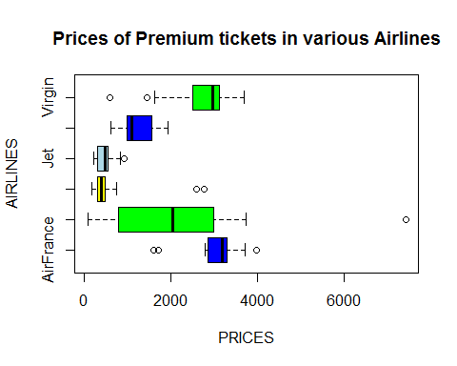

# To visualize correlation matrices for the variables in the dataset  
  
corrplot(corr = cor(airline.df[,c(3,8:13)], use = "complete.obs"), method = "ellipse")

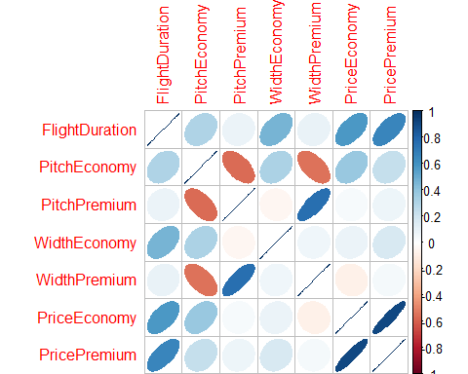

# From the the above data visualization we can take two very important inferences  
# They are:  
# 1. Price Premium is highly correlated with the flight duration and Price Economy  
# 2. Width Premium and Width Economy are highly correlated with Pitch Premium and Pitch Economy respectively.  
  
# To study analyse further we will visualize them using scatter plots  
  
# To study relation between Prices of Premium and Economy tickets  
  
plot(x=airline.df$PriceEconomy,y=airline.df$PricePremium, main = "Relation between Prices of Premium  
 and Economy class", xlab= "Price Of Premium tickets", ylab="Price Of Economy tickets", col="blue")

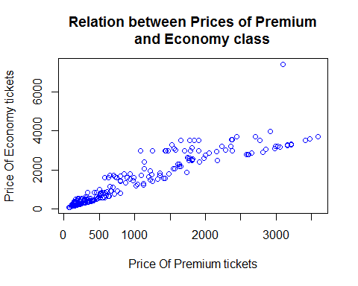

# To perform correlation test  
  
cor.test(airline.df$PriceEconomy,airline.df$PricePremium)

##   
## Pearson's product-moment correlation  
##   
## data: airline.df$PriceEconomy and airline.df$PricePremium  
## t = 44.951, df = 460, p-value < 2.2e-16  
## alternative hypothesis: true correlation is not equal to 0  
## 95 percent confidence interval:  
## 0.8840959 0.9181614  
## sample estimates:  
## cor   
## 0.9025311

# From the correlation test we can say that since, the p-value<0.05, therefore, it fails the null hypothesis and the correlation between the two variables is 0.9025311.  
# The inference from this analyzation is that if the Prices of Economy tickets of an airlines is high then the prices of its premium tickets will also become higher  
  
# To study the relation between Price Of premium class tickets and fight duaration  
  
plot(x=airline.df$FlightDuration,y=airline.df$PricePremium, main="Relation between Price of premium tickets  
 and Flight Duration", xlab="Flight duration", ylab="Premium Price",col= "magenta")

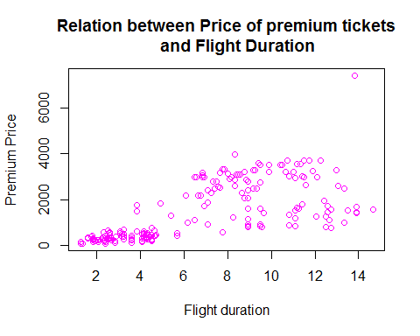

# To do the correlation test of the above two variables  
  
cor.test(airline.df$FlightDuration,airline.df$PricePremium)

##   
## Pearson's product-moment correlation  
##   
## data: airline.df$FlightDuration and airline.df$PricePremium  
## t = 18.438, df = 460, p-value < 2.2e-16  
## alternative hypothesis: true correlation is not equal to 0  
## 95 percent confidence interval:  
## 0.5961146 0.7014071  
## sample estimates:  
## cor   
## 0.6518918

# To find the relation between the price of the premium tickets and the Aircraft carrier  
  
# To Draw boxplot between PRICE_PREMIUM and AIRCRAFT  
  
boxplot(PricePremium~Aircraft, data = airline.df,  
 main="Relation between Premium Price tickets and Aircraft",  
 xlab="Price of Tickets(In US Dollars)",  
 ylab="Aircraft", col= c("Blue","green","yellow"), horizontal= TRUE)

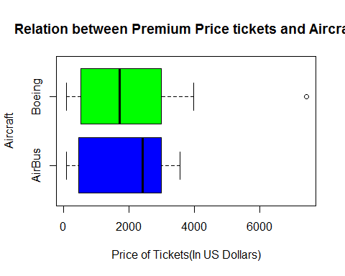

# The above graph shows that the price of premium tickets also depends on the AIrcraft carriers  
  
  
# To construct boxplot between Price of Premium tickets and Route of Flights  
  
boxplot(PricePremium~IsInternational, data = airline.df,  
 main="Relation between PRice of Premium Tickets and The route of Airline",  
 xlab="Price Of Premium Ticket(In US Dollars)",  
 ylab="AIRCRAFT Route",horizontal= TRUE,col= c("Blue","Green"))

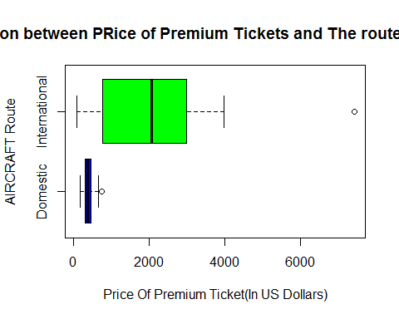

# The above boxplot shows that the price of the premium tickets also depends on the route of the airline that is International/Domestic  
  
#To construct histogram showing relation between PricePremium and airlines segmented by the route of airlines  
  
  
  
# To check the relation between the Price of Premium tickets and the No.of premium seats  
  
plot(jitter(airline.df$SeatsPremium),jitter(airline.df$PricePremium),  
 main = "Relationship between the total number of premium seats and the price of the premium tickets",  
 xlab="Total seats",  
 ylab="Price of the premium ticket",  
 cex= 0.8, col= "green")  
  
# To draw the best fit line  
  
x1<-lm(PricePremium~SeatsPremium, data= airline.df)  
  
abline(x1, col="blue")

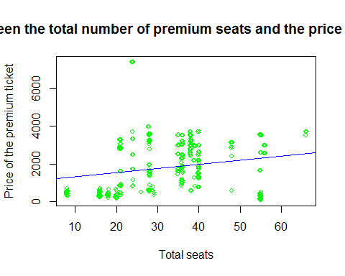

# To do the correlation test between the total number of premium seats and the price of the premium tickets  
  
cor.test(airline.df$SeatsPremium,airline.df$PricePremium)

##   
## Pearson's product-moment correlation  
##   
## data: airline.df$SeatsPremium and airline.df$PricePremium  
## t = 4.9526, df = 460, p-value = 1.03e-06  
## alternative hypothesis: true correlation is not equal to 0  
## 95 percent confidence interval:  
## 0.1365718 0.3098659  
## sample estimates:  
## cor   
## 0.2249974

# The inference we get from the correlation test is that:  
# 1. They are weakly correlated to each other  
# 2. Since, p<0.05 therefore, it fails the null hypothesis and the two variables are dependent  
  
##Correlation test to find correlation between different variables  
# Correlation matrix, covariance matrix and Corrgram  
  
x<-airline.df[,c("FlightDuration","SeatsEconomy","SeatsPremium","PricePremium","PriceEconomy","PitchEconomy","PitchPremium","WidthEconomy","WidthPremium","PitchDifference","WidthDifference","SeatsTotal","PriceRelative","FractionPremiumSeats")]  
y<-airline.df[,c("PricePremium","PriceRelative")]  
  
cor(x,y)

## PricePremium PriceRelative  
## FlightDuration 0.65189180 0.10822471  
## SeatsEconomy 0.19528776 -0.02450914  
## SeatsPremium 0.22499740 -0.10723562  
## PricePremium 1.00000000 0.01757342  
## PriceEconomy 0.90253105 -0.29810431  
## PitchEconomy 0.23983878 -0.43465185  
## PitchPremium 0.07133125 0.42782361  
## WidthEconomy 0.16310757 -0.06093642  
## WidthPremium 0.04932498 0.51167702  
## PitchDifference -0.03618869 0.47933392  
## WidthDifference -0.03079703 0.49639314  
## SeatsTotal 0.20955518 -0.03835229  
## PriceRelative 0.01757342 1.00000000  
## FractionPremiumSeats 0.03550282 -0.05005721

cov(x,y)

## PricePremium PriceRelative  
## FlightDuration 2.976982e+03 1.735896e-01  
## SeatsEconomy 1.963922e+04 -8.657126e-01  
## SeatsPremium 3.847355e+03 -6.440510e-01  
## PricePremium 1.664025e+06 1.027099e+01  
## PriceEconomy 1.152371e+06 -1.336887e+02  
## PitchEconomy 2.048238e+02 -1.303764e-01  
## PitchPremium 1.216944e+02 2.563610e-01  
## WidthEconomy 1.179328e+02 -1.547511e-02  
## WidthPremium 7.008986e+01 2.553763e-01  
## PitchDifference -8.312935e+01 3.867374e-01  
## WidthDifference -4.784293e+01 2.708514e-01  
## SeatsTotal 2.348657e+04 -1.509764e+00  
## PriceRelative 1.027099e+01 2.052828e-01  
## FractionPremiumSeats 2.801268e+00 -1.387251e-03

corrgram(airline.df,order = TRUE,upper.panel = panel.pie,lower.panel = panel.shade,text.panel = panel.txt,main="Corrgram For Airline Pricing")

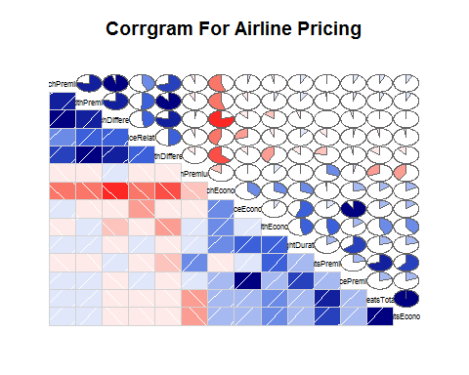

# To analyze the relationship between Price of the PricePremium, SeatsPremium, PriceEconomy, SeatsEconomy, PriceRelative, SeatsTotal,FractionPremiumSeats,PitchDifference and WidthDifference  
# using scatterplot matrix and correlations plots  
  
# Using correlation plots  
  
corrplot(corr = cor(airline.df[,c(6,7,12:18)],use = "complete.obs"), method = "ellipse")

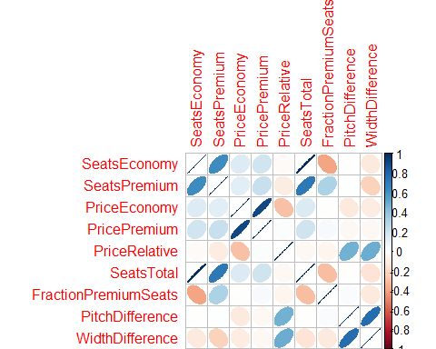

# To analyze the relationship between Price of Premium seats and No.of Premium seats.  
  
# Using Scatterplot finding the relationship between the PricePremium and SeatsPremium  
  
plot(airline.df$SeatsPremium,airline.df$PricePremium, main = "Relation between Price of premium ticket and total premium seats",  
 xlab = "Seats Premium", ylab = "Price of Premium tickets",  
 col="blue")  
abline(lm(PricePremium~SeatsPremium, data = airline.df))

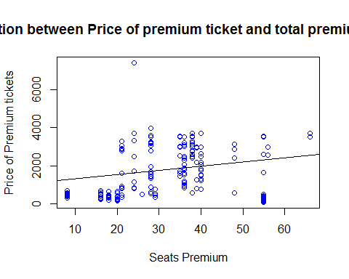

# So from all the analysis done above to get the relationship of Price Of Premium Tickets with various variables  
# Now we will try to do some regression analysis using the Dependent variable and the Independent variables  
  
# Dependent Variable = PricePremium  
# Independent variables = Airline+Aircraft+FlightDuration+SeatsPremium+PriceEconomy+IsInternational  
  
# Let us assume a value fit for our regression analysis model  
  
fit<-lm(PricePremium~Airline+Aircraft+FlightDuration+SeatsPremium+PriceEconomy+IsInternational,  
 data = airline.df)  
summary(fit)

##   
## Call:  
## lm(formula = PricePremium ~ Airline + Aircraft + FlightDuration +   
## SeatsPremium + PriceEconomy + IsInternational, data = airline.df)  
##   
## Residuals:  
## Min 1Q Median 3Q Max   
## -917.06 -194.67 -45.66 80.75 3026.90   
##   
## Coefficients:  
## Estimate Std. Error t value Pr(>|t|)   
## (Intercept) -806.47270 216.70201 -3.722 0.000223 ***  
## AirlineBritish 663.11393 97.27552 6.817 3.00e-11 ***  
## AirlineDelta 609.71950 192.15758 3.173 0.001612 **   
## AirlineJet 573.61493 125.04425 4.587 5.83e-06 ***  
## AirlineSingapore 313.32728 121.01581 2.589 0.009932 **   
## AirlineVirgin 1010.03918 99.93656 10.107 < 2e-16 ***  
## AircraftBoeing 2.37203 51.35655 0.046 0.963181   
## FlightDuration 55.65229 8.73546 6.371 4.64e-10 ***  
## SeatsPremium -0.84176 2.83954 -0.296 0.767030   
## PriceEconomy 1.16159 0.03953 29.389 < 2e-16 ***  
## IsInternationalInternational 175.35921 214.60263 0.817 0.414283   
## ---  
## Signif. codes: 0 '***' 0.001 '**' 0.01 '*' 0.05 '.' 0.1 ' ' 1  
##   
## Residual standard error: 440.2 on 451 degrees of freedom  
## Multiple R-squared: 0.8861, Adjusted R-squared: 0.8836   
## F-statistic: 350.8 on 10 and 451 DF, p-value: < 2.2e-16

residuals(fit)

## 1 2 3 4 5 6   
## 1221.674954 1221.674954 999.290936 1161.272194 868.031091 1460.678107   
## 7 8 9 10 11 12   
## 1460.678107 581.117979 703.605124 771.202911 771.202911 771.202911   
## 13 14 15 16 17 18   
## -44.465137 -44.465137 -44.465137 -44.465137 -44.465137 -44.465137   
## 19 20 21 22 23 24   
## -44.465137 -44.465137 19.589912 19.589912 19.589912 28.640247   
## 25 26 27 28 29 30   
## 28.640247 17.850663 9.533395 9.533395 13.053654 -123.622938   
## 31 32 33 34 35 36   
## -123.622938 -123.622938 -216.653508 -216.653508 -216.653508 -90.663887   
## 37 38 39 40 41 42   
## -90.663887 -90.663887 -157.971281 -111.779881 -111.779881 -177.316772   
## 43 44 45 46 47 48   
## -182.325478 -182.325478 -184.697507 -146.437163 -318.059675 -318.059675   
## 49 50 51 52 53 54   
## -318.059675 -318.059675 -191.878473 -191.878473 -191.878473 -196.330656   
## 55 56 57 58 59 60   
## -263.534906 -263.534906 -267.430567 -267.430567 -262.421861 -262.421861   
## 61 62 63 64 65 66   
## -267.430567 -267.430567 -324.716011 -324.716011 -324.716011 -476.569235   
## 67 68 69 70 71 72   
## -476.569235 -450.871585 -450.871585 -436.975847 -436.975847 -436.975847   
## 73 74 75 76 77 78   
## -436.975847 -511.704342 3026.901529 3026.901529 3026.901529 -101.871104   
## 79 80 81 82 83 84   
## -101.871104 -101.871104 -101.871104 186.982323 186.982323 186.982323   
## 85 86 87 88 89 90   
## 186.982323 819.325904 819.325904 819.325904 819.325904 1007.802761   
## 91 92 93 94 95 96   
## 1007.802761 -297.826140 20.406404 20.406404 20.406404 -92.293136   
## 97 98 99 100 101 102   
## -92.293136 -92.293136 -92.293136 803.028097 803.028097 803.028097   
## 103 104 105 106 107 108   
## -263.652204 -263.652204 -263.652204 -263.652204 461.441433 461.441433   
## 109 110 111 112 113 114   
## 461.441433 920.048754 920.048754 919.206998 367.782844 367.782844   
## 115 116 117 118 119 120   
## 128.494985 -413.968268 937.322516 937.322516 937.322516 937.322516   
## 121 122 123 124 125 126   
## -189.562738 -189.562738 -189.562738 -21.940959 -21.940959 -21.940959   
## 127 128 129 130 131 132   
## -163.713763 -163.713763 -163.713763 21.178511 21.178511 21.178511   
## 133 134 135 136 137 138   
## 21.340103 -112.442687 -112.442687 -112.442687 -157.270598 -157.270598   
## 139 140 141 142 143 144   
## -157.270598 -802.022637 -802.022637 -802.022637 598.854475 -63.018888   
## 145 146 147 148 149 150   
## -63.018888 -63.018888 -25.265766 -25.265766 -25.265766 -42.950505   
## 151 152 153 154 155 156   
## -42.950505 -42.950505 -79.395783 -79.395783 -79.395783 -98.134133   
## 157 158 159 160 161 162   
## -98.134133 -98.134133 -194.833939 -222.712136 -222.712136 224.854475   
## 163 164 165 166 167 168   
## -548.610398 -548.610398 -548.610398 -29.073121 -29.073121 -29.073121   
## 169 170 171 172 173 174   
## 162.231668 162.231668 56.526837 -580.025331 107.452788 107.452788   
## 175 176 177 178 179 180   
## 107.452788 107.452788 192.032251 192.032251 -364.370101 68.090771   
## 181 182 183 184 185 186   
## -607.482245 -295.904200 -295.904200 -295.904200 -123.638564 -123.638564   
## 187 188 189 190 191 192   
## -123.638564 -123.638564 -293.894801 -293.894801 -293.894801 -643.929638   
## 193 194 195 196 197 198   
## -618.886108 -551.300935 -551.300935 -551.300935 -610.004781 -610.004781   
## 199 200 201 202 203 204   
## -111.905141 -365.412273 -324.947366 -324.947366 -402.824922 -647.107723   
## 205 206 207 208 209 210   
## -470.447709 -358.993231 -426.365540 -528.519026 -528.519026 -528.519026   
## 211 212 213 214 215 216   
## -257.612557 -209.898877 -209.898877 -168.169783 -184.100410 -184.100410   
## 217 218 219 220 221 222   
## -210.971553 -155.731658 -152.788135 -152.788135 -134.425164 -170.810115   
## 223 224 225 226 227 228   
## -86.006357 -185.397863 -237.982053 -141.153544 -233.942265 -84.027470   
## 229 230 231 232 233 234   
## -123.275347 -191.388525 -213.174881 -140.832012 -233.286560 -42.892058   
## 235 236 237 238 239 240   
## -208.519177 -44.779312 -115.125530 -77.908104 -77.908104 -40.882720   
## 241 242 243 244 245 246   
## -40.882720 -43.254749 -174.744595 -130.874238 -52.536003 -52.536003   
## 247 248 249 250 251 252   
## -40.791087 -108.783671 -51.596904 112.487364 112.487364 -32.337547   
## 253 254 255 256 257 258   
## -32.337547 -32.337547 -127.962087 -36.197387 -34.527818 -31.336606   
## 259 260 261 262 263 264   
## -62.795054 -63.908100 -64.464623 -72.245025 -72.245025 -72.245025   
## 265 266 267 268 269 270   
## -55.848513 -49.726762 -52.947991 -73.860941 -56.552962 -46.548003   
## 271 272 273 274 275 276   
## -54.339323 -56.231042 -55.820860 93.096218 91.558645 86.041107   
## 277 278 279 280 281 282   
## 57.967013 51.408233 49.036204 66.005651 -105.293631 18.847333   
## 283 284 285 286 287 288   
## 74.729699 78.481863 61.642679 -103.414511 78.827839 77.714793   
## 289 290 291 292 293 294   
## 89.812359 -6.686660 59.508601 65.642486 80.763232 41.820572   
## 295 296 297 298 299 300   
## 4.331333 176.738893 176.738893 176.738893 124.263456 58.388719   
## 301 302 303 304 305 306   
## 111.083794 111.083794 112.647541 128.247563 125.985281 -2.816079   
## 307 308 309 310 311 312   
## -40.348999 -40.348999 -40.348999 -40.348999 -1.927944 9.072888   
## 313 314 315 316 317 318   
## 9.072888 9.072888 59.396095 59.396095 59.396095 7.278691   
## 319 320 321 322 323 324   
## 23.107645 23.107645 23.107645 112.088408 97.186921 98.912259   
## 325 326 327 328 329 330   
## -21.675000 -26.127183 -110.844093 80.725437 -149.176614 25.709940   
## 331 332 333 334 335 336   
## 1.037405 22.483924 22.483924 22.483924 -84.264889 -84.264889   
## 337 338 339 340 341 342   
## -84.264889 -84.264889 28.653019 -59.461013 42.870446 39.608164   
## 343 344 345 346 347 348   
## -3.307797 20.083228 20.083228 20.083228 20.083228 26.872882   
## 349 350 351 352 353 354   
## 26.872882 -278.692960 -278.692960 -293.333332 -274.922355 -9.613095   
## 355 356 357 358 359 360   
## -15.691842 -15.691842 -15.691842 -44.731631 -106.260698 -105.134019   
## 361 362 363 364 365 366   
## 313.556311 23.640670 23.640670 23.640670 23.640670 422.667583   
## 367 368 369 370 371 372   
## 422.667583 422.667583 422.667583 94.556311 94.556311 50.556311   
## 373 374 375 376 377 378   
## -47.966733 -47.966733 -47.966733 -47.966733 294.851368 294.851368   
## 379 380 381 382 383 384   
## 294.851368 294.851368 184.004703 184.004703 184.004703 74.714855   
## 385 386 387 388 389 390   
## -71.140202 -71.140202 -526.076933 -526.076933 -526.076933 -240.122431   
## 391 392 393 394 395 396   
## -240.122431 -240.122431 90.859033 90.859033 90.859033 90.859033   
## 397 398 399 400 401 402   
## -468.820850 -468.820850 -468.820850 -468.820850 -25.678080 -25.678080   
## 403 404 405 406 407 408   
## -25.678080 -25.678080 678.395647 678.395647 678.395647 491.379408   
## 409 410 411 412 413 414   
## 584.781419 584.781419 584.781419 584.781419 569.359830 569.359830   
## 415 416 417 418 419 420   
## 569.359830 569.359830 562.949410 562.949410 562.949410 562.949410   
## 421 422 423 424 425 426   
## 229.134784 229.134784 229.134784 229.134784 372.211971 372.211971   
## 427 428 429 430 431 432   
## 372.211971 367.314675 238.294782 238.294782 238.294782 238.294782   
## 433 434 435 436 437 438   
## -615.046413 -70.095301 -70.095301 -70.095301 -70.095301 -719.493835   
## 439 440 441 442 443 444   
## -189.289796 -189.289796 -194.187092 -312.854711 -312.854711 -312.854711   
## 445 446 447 448 449 450   
## -312.854711 -350.775107 -350.775107 -350.775107 -350.775107 -357.516998   
## 451 452 453 454 455 456   
## -357.516998 -357.516998 -357.516998 -561.051371 -552.633816 -552.633816   
## 457 458 459 460 461 462   
## -552.633816 -917.060215 -811.503659 -803.086104 -811.503659 -811.503659

# From the summary details of the linear model we made, we made some inferences given below:  
# 1. The P-value is 2.2e-16<0.05 thus failing the null Hypothesis  
# 2. The multiple R-squared: 0.8861 accounts for 88.61% variance in Price Of Premium Tickets.  
  
  
# To Visualize the relation between Relative Price Of Tickets and The Pitch Differnce  
  
scatterplot(airline.df$PitchDifference,airline.df$PriceRelative,main="Relation Between Pitch Differnce and Relative Price of tickets",xlab="Pitch Difference",ylab="Relative Price",pch=19)

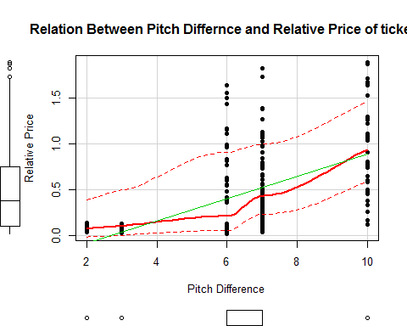

# To run the correlation test for the above relationship between the two variables  
  
cor.test(airline.df$PitchDifference,airline.df$PriceRelative)

##   
## Pearson's product-moment correlation  
##   
## data: airline.df$PitchDifference and airline.df$PriceRelative  
## t = 11.714, df = 460, p-value < 2.2e-16  
## alternative hypothesis: true correlation is not equal to 0  
## 95 percent confidence interval:  
## 0.4058526 0.5466580  
## sample estimates:  
## cor   
## 0.4793339

# From the correlation test we have found that:  
# 1.p-value<0.05, thus, it fails the null hypothesis that the two variables are independent  
# 2.The correlation between the two variables is 0.479339.  
  
# To visualize the relation between Width difference and the Reative Price of the tickets  
  
scatterplot(airline.df$WidthDifference,airline.df$PriceRelative,  
 main="Relation Betwen Width Differnce and Relative Price Of Tickets",  
 xlab = "Width Difference",ylab = "Relative Price",  
 cex=1.1,pch=19)

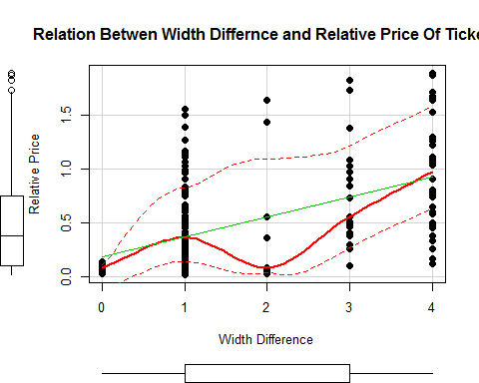

# To run the correlation test between Relative Price and the Width Differnce  
  
cor.test(airline.df$WidthDifference,airline.df$PriceRelative)

##   
## Pearson's product-moment correlation  
##   
## data: airline.df$WidthDifference and airline.df$PriceRelative  
## t = 12.264, df = 460, p-value < 2.2e-16  
## alternative hypothesis: true correlation is not equal to 0  
## 95 percent confidence interval:  
## 0.4243826 0.5621642  
## sample estimates:  
## cor   
## 0.4963931

# From the correlation test run , we generated the following inferences:  
# 1. p-value<0.05, thus, fails the null hypothesis that the two variables are independent  
# 2. The correlation coeffecient=0.4963931  
  
# To visualise the relation between Relative Price Of tickets and the Flight Duration  
  
scatterplot(airline.df$FlightDuration,airline.df$PriceRelative,  
 main="Relation between Flight Duration and Relative Price Of Tickets",  
 xlab = "Flight Duration",  
 ylab="Relative Price Of Tickets",  
 cex=1.1,pch=19)

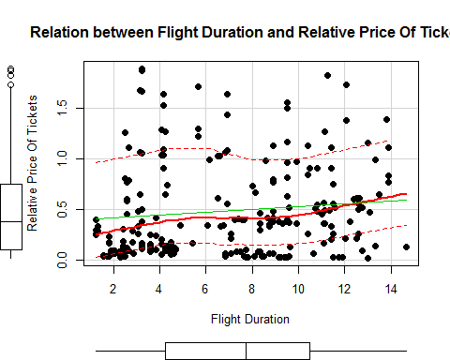

# To run the correlation test between Relative Price Of the Tickets and the Flight Duaration  
  
cor.test(airline.df$FlightDuration,airline.df$PriceRelative)

##   
## Pearson's product-moment correlation  
##   
## data: airline.df$FlightDuration and airline.df$PriceRelative  
## t = 2.3349, df = 460, p-value = 0.01998  
## alternative hypothesis: true correlation is not equal to 0  
## 95 percent confidence interval:  
## 0.01716526 0.19750364  
## sample estimates:  
## cor   
## 0.1082247

# From the analysis we generated the inference given below:  
# 1. 0.01<p-value<0.05, thus fails the null hypothesis that the two variables are independent, but are quiet similar to each other or they have very less significant differnce in them.  
# 2. The Correlation coeffecient is 0.1082247.  
  
# To visualize the Relation between Relative Price Of tickets and and the Route of Airlines that is International/Domestic  
  
scatterplot(airline.df$IsInternational,airline.df$PriceRelative,  
 main="Relation between Flight Type and Relative Price Of Tickets",  
 xlab = "IsInternational",  
 ylab = "Relative Price Of tickets",  
 cex = 1.1,pch = 19,  
 col= c("Blue","Yellow"))

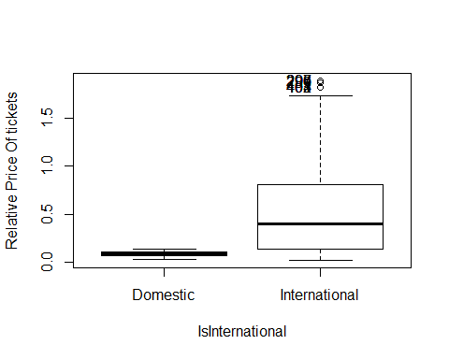

## [1] "296" "297" "298" "299" "401" "402" "403" "404"

# To run the T-Test for the above relationship  
  
t.test(PriceRelative~IsInternational,var.equal=TRUE)

##   
## Two Sample t-test  
##   
## data: PriceRelative by IsInternational  
## t = -6.1942, df = 460, p-value = 1.301e-09  
## alternative hypothesis: true difference in means is not equal to 0  
## 95 percent confidence interval:  
## -0.5882235 -0.3048831  
## sample estimates:  
## mean in group Domestic mean in group International   
## 0.0847500 0.5313033

# After running the T-Test to analyse the results, we generated the following inferences:  
# 1. p-value<0.05, thus fails the null hypothesis that the two variables are independent and they have significant difference in there values  
# 2.mean in group domestic=0.0847500 and mean in group International=0.5313033.  
  
scatterplot(airline.df$Aircraft,airline.df$PriceRelative,main="Relation between Relative Price and Airline",  
 xlab = "Airline",  
 ylab = "Relative Price Of Tickets",  
 cex = 1.1,pch = 19)

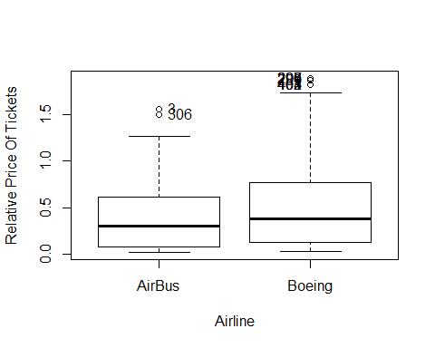

## [1] "3" "306" "296" "297" "298" "299" "401" "402" "403" "404"

# To run the t-test between Relative price of the tickets and the Aircraft carrier to show that average Relative Price of Boeing is Higher than the average Relative Price Of Airbus.  
  
t.test(PriceRelative~Aircraft,var.equal=TRUE)

##   
## Two Sample t-test  
##   
## data: PriceRelative by Aircraft  
## t = -2.5901, df = 460, p-value = 0.0099  
## alternative hypothesis: true difference in means is not equal to 0  
## 95 percent confidence interval:  
## -0.20345244 -0.02791145  
## sample estimates:  
## mean in group AirBus mean in group Boeing   
## 0.4147682 0.5304502

# After running the T-Test for the, the following inferences can be drawn:  
# 1. p-value<0.05, thus fails the null hypothesis.  
  
## To run and test the linear regression model  
# Dependent variable = PriceRelative  
# Independent Variables = PitchDifference+WidthDifference+Aircraft+IsInternational  
  
model3<-lm(PriceRelative~PitchDifference+WidthDifference+Aircraft+IsInternational  
,data = airline.df)  
  
#Summary   
  
summary(model3)

##   
## Call:  
## lm(formula = PriceRelative ~ PitchDifference + WidthDifference +   
## Aircraft + IsInternational, data = airline.df)  
##   
## Residuals:  
## Min 1Q Median 3Q Max   
## -0.88283 -0.26283 -0.08947 0.21301 1.23212   
##   
## Coefficients:  
## Estimate Std. Error t value Pr(>|t|)   
## (Intercept) -0.13614 0.08461 -1.609 0.10831   
## PitchDifference 0.07583 0.02409 3.147 0.00176 **   
## WidthDifference 0.10862 0.02519 4.313 1.98e-05 ***  
## AircraftBoeing 0.04576 0.04098 1.117 0.26470   
## IsInternationalInternational -0.09958 0.10915 -0.912 0.36208   
## ---  
## Signif. codes: 0 '***' 0.001 '**' 0.01 '*' 0.05 '.' 0.1 ' ' 1  
##   
## Residual standard error: 0.3876 on 457 degrees of freedom  
## Multiple R-squared: 0.2747, Adjusted R-squared: 0.2683   
## F-statistic: 43.27 on 4 and 457 DF, p-value: < 2.2e-16

residuals(model3)

## 1 2 3 4 5   
## 1.1577347910 1.1577347910 1.2321185600 0.9577347910 0.8421185600   
## 6 7 8 9 10   
## 0.8321185600 0.8321185600 0.3021185600 0.0777347910 -0.1222652090   
## 11 12 13 14 15   
## -0.1222652090 -0.1222652090 -0.2478814400 -0.2478814400 -0.2478814400   
## 16 17 18 19 20   
## -0.2478814400 -0.2478814400 -0.2478814400 -0.2478814400 -0.2478814400   
## 21 22 23 24 25   
## -0.2478814400 -0.2478814400 -0.2478814400 -0.2478814400 -0.2478814400   
## 26 27 28 29 30   
## -0.4022652090 -0.2578814400 -0.2578814400 -0.4122652090 -0.4122652090   
## 31 32 33 34 35   
## -0.4122652090 -0.4122652090 -0.3036409243 -0.3036409243 -0.3036409243   
## 36 37 38 39 40   
## -0.2578814400 -0.2578814400 -0.2578814400 -0.4422652090 -0.4422652090   
## 41 42 43 44 45   
## -0.4422652090 -0.2878814400 -0.2878814400 -0.2878814400 -0.3336409243   
## 46 47 48 49 50   
## -0.2878814400 -0.4522652090 -0.4522652090 -0.4522652090 -0.4522652090   
## 51 52 53 54 55   
## -0.4522652090 -0.4522652090 -0.4522652090 -0.4522652090 -0.2978814400   
## 56 57 58 59 60   
## -0.2978814400 -0.2978814400 -0.2978814400 -0.2978814400 -0.2978814400   
## 61 62 63 64 65   
## -0.2978814400 -0.2978814400 -0.4522652090 -0.4522652090 -0.4522652090   
## 66 67 68 69 70   
## -0.4522652090 -0.4522652090 -0.3436409243 -0.3436409243 -0.4522652090   
## 71 72 73 74 75   
## -0.4522652090 -0.4522652090 -0.4522652090 -0.3078814400 0.9405292866   
## 76 77 78 79 80   
## 0.9405292866 0.9405292866 -0.0694707134 -0.0694707134 -0.0694707134   
## 81 82 83 84 85   
## -0.0694707134 0.0862887709 0.0862887709 0.0862887709 0.0862887709   
## 86 87 88 89 90   
## 0.5062887709 0.5062887709 0.5062887709 0.5062887709 0.6805292866   
## 91 92 93 94 95   
## 0.6805292866 -0.1894707134 0.0005292866 0.0005292866 0.0005292866   
## 96 97 98 99 100   
## -0.0894707134 -0.0894707134 -0.0894707134 -0.0894707134 0.5305292866   
## 101 102 103 104 105   
## 0.5305292866 0.5305292866 -0.1194707134 -0.1194707134 -0.1194707134   
## 106 107 108 109 110   
## -0.1194707134 0.2205292866 0.2205292866 0.2205292866 0.5805292866   
## 111 112 113 114 115   
## 0.5805292866 0.5805292866 0.3005292866 0.3005292866 0.1105292866   
## 116 117 118 119 120   
## -0.1894707134 0.6205292866 0.6205292866 0.6205292866 0.6205292866   
## 121 122 123 124 125   
## -0.0894707134 -0.0894707134 -0.0894707134 0.0705292866 0.0705292866   
## 126 127 128 129 130   
## 0.0705292866 0.0662887709 0.0662887709 0.0662887709 -0.0494707134   
## 131 132 133 134 135   
## -0.0494707134 -0.0494707134 -0.0494707134 -0.0694707134 -0.0694707134   
## 136 137 138 139 140   
## -0.0694707134 -0.0894707134 -0.0894707134 -0.0894707134 -0.3094707134   
## 141 142 143 144 145   
## -0.3094707134 -0.3094707134 0.6805292866 -0.0294707134 -0.0294707134   
## 146 147 148 149 150   
## -0.0294707134 -0.0494707134 -0.0494707134 -0.0494707134 -0.1094707134   
## 151 152 153 154 155   
## -0.1094707134 -0.1094707134 -0.1094707134 -0.1094707134 -0.1094707134   
## 156 157 158 159 160   
## -0.1194707134 -0.1194707134 -0.1194707134 -0.0994707134 -0.1194707134   
## 161 162 163 164 165   
## -0.1194707134 0.3505292866 -0.3794707134 -0.3794707134 -0.3794707134   
## 166 167 168 169 170   
## -0.1094707134 -0.1094707134 -0.1094707134 0.6605292866 0.6605292866   
## 171 172 173 174 175   
## 0.4605292866 -0.2494707134 -0.0294707134 -0.0294707134 -0.0294707134   
## 176 177 178 179 180   
## -0.0294707134 0.8662887709 0.8662887709 -0.0437112291 0.3505292866   
## 181 182 183 184 185   
## -0.2794707134 0.2005292866 0.2005292866 0.2005292866 -0.2094707134   
## 186 187 188 189 190   
## -0.2094707134 -0.2094707134 -0.2094707134 -0.2794707134 -0.2794707134   
## 191 192 193 194 195   
## -0.2794707134 -0.2394707134 -0.2394707134 -0.3694707134 -0.3694707134   
## 196 197 198 199 200   
## -0.3694707134 -0.2794707134 -0.2794707134 0.3205292866 -0.2394707134   
## 201 202 203 204 205   
## 0.0305292866 0.0305292866 0.1205292866 -0.4094707134 0.1605292866   
## 206 207 208 209 210   
## 0.0705292866 -0.0794707134 0.0705292866 0.0705292866 0.0705292866   
## 211 212 213 214 215   
## -0.3437112291 -0.3037112291 -0.3037112291 -0.3637112291 -0.2937112291   
## 216 217 218 219 220   
## -0.2937112291 -0.3237112291 -0.3137112291 -0.3537112291 -0.3537112291   
## 221 222 223 224 225   
## -0.2937112291 -0.2637112291 -0.2337112291 -0.2437112291 -0.2537112291   
## 226 227 228 229 230   
## -0.3337112291 -0.2337112291 -0.2237112291 -0.2637112291 -0.2737112291   
## 231 232 233 234 235   
## -0.2437112291 -0.2237112291 -0.2237112291 -0.1537112291 -0.2037112291   
## 236 237 238 239 240   
## -0.1894707134 -0.2137112291 -0.1737112291 -0.1737112291 -0.1037112291   
## 241 242 243 244 245   
## -0.1037112291 -0.1494707134 -0.1537112291 -0.1137112291 -0.1594707134   
## 246 247 248 249 250   
## -0.1594707134 -0.0494707134 -0.0937112291 -0.1194707134 -0.1609597984   
## 251 252 253 254 255   
## -0.1609597984 -0.2409597984 -0.2409597984 -0.2409597984 -0.3209597984   
## 256 257 258 259 260   
## 0.0787179930 0.0787179930 -0.0071117961 0.0587179930 0.0587179930   
## 261 262 263 264 265   
## 0.0587179930 -0.0271117961 -0.0271117961 -0.0271117961 0.0487179930   
## 266 267 268 269 270   
## 0.0487179930 0.0487179930 -0.0371117961 -0.0371117961 0.0387179930   
## 271 272 273 274 275   
## 0.0387179930 -0.0471117961 0.0287179930 0.0287179930 0.0744774773   
## 276 277 278 279 280   
## -0.0471117961 0.0644774773 0.0644774773 0.0187179930 -0.0571117961   
## 281 282 283 284 285   
## 0.0087179930 0.0087179930 -0.0671117961 -0.0671117961 -0.0671117961   
## 286 287 288 289 290   
## -0.0771117961 0.0344774773 0.0344774773 -0.0112820070 -0.0212820070   
## 291 292 293 294 295   
## 0.0244774773 -0.0971117961 -0.0212820070 -0.0971117961 -0.1071117961   
## 296 297 298 299 300   
## 0.8871670653 0.8871670653 0.8871670653 0.8671670653 0.7071670653   
## 301 302 303 304 305   
## 0.6771670653 0.6771670653 0.6671670653 0.6371670653 0.5271670653   
## 306 307 308 309 310   
## 1.1721185600 0.2971670653 0.2971670653 0.2971670653 0.2971670653   
## 311 312 313 314 315   
## 0.2871670653 0.2671670653 0.2671670653 0.2671670653 0.2571670653   
## 316 317 318 319 320   
## 0.2571670653 0.2571670653 0.2171670653 0.1071670653 0.1071670653   
## 321 322 323 324 325   
## 0.1071670653 0.0871670653 0.0671670653 0.0571670653 0.0371670653   
## 326 327 328 329 330   
## 0.0371670653 0.6321185600 -0.0928329347 0.4921185600 -0.1928329347   
## 331 332 333 334 335   
## -0.2128329347 -0.2328329347 -0.2328329347 -0.2328329347 -0.2628329347   
## 336 337 338 339 340   
## -0.2628329347 -0.2628329347 -0.2628329347 -0.3528329347 -0.3528329347   
## 341 342 343 344 345   
## -0.4028329347 -0.4228329347 -0.5028329347 -0.5228329347 -0.5228329347   
## 346 347 348 349 350   
## -0.5228329347 -0.5228329347 -0.5528329347 -0.5528329347 0.0921185600   
## 351 352 353 354 355   
## 0.0921185600 0.0721185600 0.0521185600 -0.6228329347 -0.6728329347   
## 356 357 358 359 360   
## -0.6728329347 -0.6728329347 -0.7428329347 -0.8328329347 -0.8828329347   
## 361 362 363 364 365   
## 0.7363590757 0.6621185600 0.6621185600 0.6621185600 0.6621185600   
## 366 367 368 369 370   
## 0.6621185600 0.6621185600 0.6621185600 0.6621185600 0.4563590757   
## 371 372 373 374 375   
## 0.4563590757 0.3963590757 0.2821185600 0.2821185600 0.2821185600   
## 376 377 378 379 380   
## 0.2821185600 0.2821185600 0.2821185600 0.2821185600 0.2821185600   
## 381 382 383 384 385   
## 0.2263590757 0.2263590757 0.2263590757 0.1763590757 0.1063590757   
## 386 387 388 389 390   
## 0.1063590757 -0.2436409243 -0.2436409243 -0.2436409243 -0.2436409243   
## 391 392 393 394 395   
## -0.2436409243 -0.2436409243 -0.2736409243 -0.2736409243 -0.2736409243   
## 396 397 398 399 400   
## -0.2736409243 -0.2836409243 -0.2836409243 -0.2836409243 -0.2836409243   
## 401 402 403 404 405   
## 1.1532807173 1.1532807173 1.1532807173 1.1532807173 1.0632807173   
## 406 407 408 409 410   
## 1.0632807173 1.0632807173 0.7132807173 0.4590402016 0.4590402016   
## 411 412 413 414 415   
## 0.4590402016 0.4590402016 0.4090402016 0.4090402016 0.4090402016   
## 416 417 418 419 420   
## 0.4090402016 0.3032807173 0.3032807173 0.3032807173 0.3032807173   
## 421 422 423 424 425   
## 0.2432807173 0.2432807173 0.2432807173 0.2432807173 0.2190402016   
## 426 427 428 429 430   
## 0.2190402016 0.2190402016 0.1732807173 0.1090402016 0.1090402016   
## 431 432 433 434 435   
## 0.1090402016 0.1090402016 -0.1067192827 -0.1567192827 -0.1567192827   
## 436 437 438 439 440   
## -0.1567192827 -0.1567192827 -0.1667192827 -0.1309597984 -0.1309597984   
## 441 442 443 444 445   
## -0.1767192827 -0.2109597984 -0.2109597984 -0.2109597984 -0.2109597984   
## 446 447 448 449 450   
## -0.2667192827 -0.2667192827 -0.2667192827 -0.2667192827 -0.2309597984   
## 451 452 453 454 455   
## -0.2309597984 -0.2309597984 -0.2309597984 -0.3609597984 -0.3609597984   
## 456 457 458 459 460   
## -0.3609597984 -0.3609597984 -0.4067192827 -0.5209597984 -0.5209597984   
## 461 462   
## -0.5209597984 -0.5209597984

fitted(model3)

## 1 2 3 4 5 6   
## 0.48226521 0.48226521 0.32788144 0.48226521 0.32788144 0.32788144   
## 7 8 9 10 11 12   
## 0.32788144 0.32788144 0.48226521 0.48226521 0.48226521 0.48226521   
## 13 14 15 16 17 18   
## 0.32788144 0.32788144 0.32788144 0.32788144 0.32788144 0.32788144   
## 19 20 21 22 23 24   
## 0.32788144 0.32788144 0.32788144 0.32788144 0.32788144 0.32788144   
## 25 26 27 28 29 30   
## 0.32788144 0.48226521 0.32788144 0.32788144 0.48226521 0.48226521   
## 31 32 33 34 35 36   
## 0.48226521 0.48226521 0.37364092 0.37364092 0.37364092 0.32788144   
## 37 38 39 40 41 42   
## 0.32788144 0.32788144 0.48226521 0.48226521 0.48226521 0.32788144   
## 43 44 45 46 47 48   
## 0.32788144 0.32788144 0.37364092 0.32788144 0.48226521 0.48226521   
## 49 50 51 52 53 54   
## 0.48226521 0.48226521 0.48226521 0.48226521 0.48226521 0.48226521   
## 55 56 57 58 59 60   
## 0.32788144 0.32788144 0.32788144 0.32788144 0.32788144 0.32788144   
## 61 62 63 64 65 66   
## 0.32788144 0.32788144 0.48226521 0.48226521 0.48226521 0.48226521   
## 67 68 69 70 71 72   
## 0.48226521 0.37364092 0.37364092 0.48226521 0.48226521 0.48226521   
## 73 74 75 76 77 78   
## 0.48226521 0.32788144 0.44947071 0.44947071 0.44947071 0.44947071   
## 79 80 81 82 83 84   
## 0.44947071 0.44947071 0.44947071 0.40371123 0.40371123 0.40371123   
## 85 86 87 88 89 90   
## 0.40371123 0.40371123 0.40371123 0.40371123 0.40371123 0.44947071   
## 91 92 93 94 95 96   
## 0.44947071 0.44947071 0.44947071 0.44947071 0.44947071 0.44947071   
## 97 98 99 100 101 102   
## 0.44947071 0.44947071 0.44947071 0.44947071 0.44947071 0.44947071   
## 103 104 105 106 107 108   
## 0.44947071 0.44947071 0.44947071 0.44947071 0.44947071 0.44947071   
## 109 110 111 112 113 114   
## 0.44947071 0.44947071 0.44947071 0.44947071 0.44947071 0.44947071   
## 115 116 117 118 119 120   
## 0.44947071 0.44947071 0.44947071 0.44947071 0.44947071 0.44947071   
## 121 122 123 124 125 126   
## 0.44947071 0.44947071 0.44947071 0.44947071 0.44947071 0.44947071   
## 127 128 129 130 131 132   
## 0.40371123 0.40371123 0.40371123 0.44947071 0.44947071 0.44947071   
## 133 134 135 136 137 138   
## 0.44947071 0.44947071 0.44947071 0.44947071 0.44947071 0.44947071   
## 139 140 141 142 143 144   
## 0.44947071 0.44947071 0.44947071 0.44947071 0.44947071 0.44947071   
## 145 146 147 148 149 150   
## 0.44947071 0.44947071 0.44947071 0.44947071 0.44947071 0.44947071   
## 151 152 153 154 155 156   
## 0.44947071 0.44947071 0.44947071 0.44947071 0.44947071 0.44947071   
## 157 158 159 160 161 162   
## 0.44947071 0.44947071 0.44947071 0.44947071 0.44947071 0.44947071   
## 163 164 165 166 167 168   
## 0.44947071 0.44947071 0.44947071 0.44947071 0.44947071 0.44947071   
## 169 170 171 172 173 174   
## 0.44947071 0.44947071 0.44947071 0.44947071 0.44947071 0.44947071   
## 175 176 177 178 179 180   
## 0.44947071 0.44947071 0.40371123 0.40371123 0.40371123 0.44947071   
## 181 182 183 184 185 186   
## 0.44947071 0.44947071 0.44947071 0.44947071 0.44947071 0.44947071   
## 187 188 189 190 191 192   
## 0.44947071 0.44947071 0.44947071 0.44947071 0.44947071 0.44947071   
## 193 194 195 196 197 198   
## 0.44947071 0.44947071 0.44947071 0.44947071 0.44947071 0.44947071   
## 199 200 201 202 203 204   
## 0.44947071 0.44947071 0.44947071 0.44947071 0.44947071 0.44947071   
## 205 206 207 208 209 210   
## 0.44947071 0.44947071 0.44947071 0.44947071 0.44947071 0.44947071   
## 211 212 213 214 215 216   
## 0.40371123 0.40371123 0.40371123 0.40371123 0.40371123 0.40371123   
## 217 218 219 220 221 222   
## 0.40371123 0.40371123 0.40371123 0.40371123 0.40371123 0.40371123   
## 223 224 225 226 227 228   
## 0.40371123 0.40371123 0.40371123 0.40371123 0.40371123 0.40371123   
## 229 230 231 232 233 234   
## 0.40371123 0.40371123 0.40371123 0.40371123 0.40371123 0.40371123   
## 235 236 237 238 239 240   
## 0.40371123 0.44947071 0.40371123 0.40371123 0.40371123 0.40371123   
## 241 242 243 244 245 246   
## 0.40371123 0.44947071 0.40371123 0.40371123 0.44947071 0.44947071   
## 247 248 249 250 251 252   
## 0.44947071 0.40371123 0.44947071 0.62095980 0.62095980 0.62095980   
## 253 254 255 256 257 258   
## 0.62095980 0.62095980 0.62095980 0.06128201 0.06128201 0.13711180   
## 259 260 261 262 263 264   
## 0.06128201 0.06128201 0.06128201 0.13711180 0.13711180 0.13711180   
## 265 266 267 268 269 270   
## 0.06128201 0.06128201 0.06128201 0.13711180 0.13711180 0.06128201   
## 271 272 273 274 275 276   
## 0.06128201 0.13711180 0.06128201 0.06128201 0.01552252 0.13711180   
## 277 278 279 280 281 282   
## 0.01552252 0.01552252 0.06128201 0.13711180 0.06128201 0.06128201   
## 283 284 285 286 287 288   
## 0.13711180 0.13711180 0.13711180 0.13711180 0.01552252 0.01552252   
## 289 290 291 292 293 294   
## 0.06128201 0.06128201 0.01552252 0.13711180 0.06128201 0.13711180   
## 295 296 297 298 299 300   
## 0.13711180 1.00283293 1.00283293 1.00283293 1.00283293 1.00283293   
## 301 302 303 304 305 306   
## 1.00283293 1.00283293 1.00283293 1.00283293 1.00283293 0.32788144   
## 307 308 309 310 311 312   
## 1.00283293 1.00283293 1.00283293 1.00283293 1.00283293 1.00283293   
## 313 314 315 316 317 318   
## 1.00283293 1.00283293 1.00283293 1.00283293 1.00283293 1.00283293   
## 319 320 321 322 323 324   
## 1.00283293 1.00283293 1.00283293 1.00283293 1.00283293 1.00283293   
## 325 326 327 328 329 330   
## 1.00283293 1.00283293 0.32788144 1.00283293 0.32788144 1.00283293   
## 331 332 333 334 335 336   
## 1.00283293 1.00283293 1.00283293 1.00283293 1.00283293 1.00283293   
## 337 338 339 340 341 342   
## 1.00283293 1.00283293 1.00283293 1.00283293 1.00283293 1.00283293   
## 343 344 345 346 347 348   
## 1.00283293 1.00283293 1.00283293 1.00283293 1.00283293 1.00283293   
## 349 350 351 352 353 354   
## 1.00283293 0.32788144 0.32788144 0.32788144 0.32788144 1.00283293   
## 355 356 357 358 359 360   
## 1.00283293 1.00283293 1.00283293 1.00283293 1.00283293 1.00283293   
## 361 362 363 364 365 366   
## 0.37364092 0.32788144 0.32788144 0.32788144 0.32788144 0.32788144   
## 367 368 369 370 371 372   
## 0.32788144 0.32788144 0.32788144 0.37364092 0.37364092 0.37364092   
## 373 374 375 376 377 378   
## 0.32788144 0.32788144 0.32788144 0.32788144 0.32788144 0.32788144   
## 379 380 381 382 383 384   
## 0.32788144 0.32788144 0.37364092 0.37364092 0.37364092 0.37364092   
## 385 386 387 388 389 390   
## 0.37364092 0.37364092 0.37364092 0.37364092 0.37364092 0.37364092   
## 391 392 393 394 395 396   
## 0.37364092 0.37364092 0.37364092 0.37364092 0.37364092 0.37364092   
## 397 398 399 400 401 402   
## 0.37364092 0.37364092 0.37364092 0.37364092 0.66671928 0.66671928   
## 403 404 405 406 407 408   
## 0.66671928 0.66671928 0.66671928 0.66671928 0.66671928 0.66671928   
## 409 410 411 412 413 414   
## 0.62095980 0.62095980 0.62095980 0.62095980 0.62095980 0.62095980   
## 415 416 417 418 419 420   
## 0.62095980 0.62095980 0.66671928 0.66671928 0.66671928 0.66671928   
## 421 422 423 424 425 426   
## 0.66671928 0.66671928 0.66671928 0.66671928 0.62095980 0.62095980   
## 427 428 429 430 431 432   
## 0.62095980 0.66671928 0.62095980 0.62095980 0.62095980 0.62095980   
## 433 434 435 436 437 438   
## 0.66671928 0.66671928 0.66671928 0.66671928 0.66671928 0.66671928   
## 439 440 441 442 443 444   
## 0.62095980 0.62095980 0.66671928 0.62095980 0.62095980 0.62095980   
## 445 446 447 448 449 450   
## 0.62095980 0.66671928 0.66671928 0.66671928 0.66671928 0.62095980   
## 451 452 453 454 455 456   
## 0.62095980 0.62095980 0.62095980 0.62095980 0.62095980 0.62095980   
## 457 458 459 460 461 462   
## 0.62095980 0.66671928 0.62095980 0.62095980 0.62095980 0.62095980

## model3:PriceRelative= b0 +b1*PitchDiffernece+b2*WidthDifference+b3*Aircraft+b4*IsInternational  
## b0=-0.13614,b1=0.07583,b2=0.10862,b3=0.04576,b4=-0.09958  
## Model: -0.13614+0.07583*PitchDiffernece+0.10862*WidthDifference+0.04576*Aircraft+-0.09958*IsInternational